**Linux Task Day-1:-**

1. **Create linux user and set password for the user.**
2. **Switch the user and create directory including its sub directory under newly created user’s home directory.**
3. **Create file using cat and echo command.**
4. **Change the executable file permission for the file.**
5. **Change the owner of the file.**
6. **Create linux user and set password for the user:**

* Create the user with the **adduser** or **useradd** command and the **-m** option to create a home directory.
* Set the password for the user with the **passwd** command.

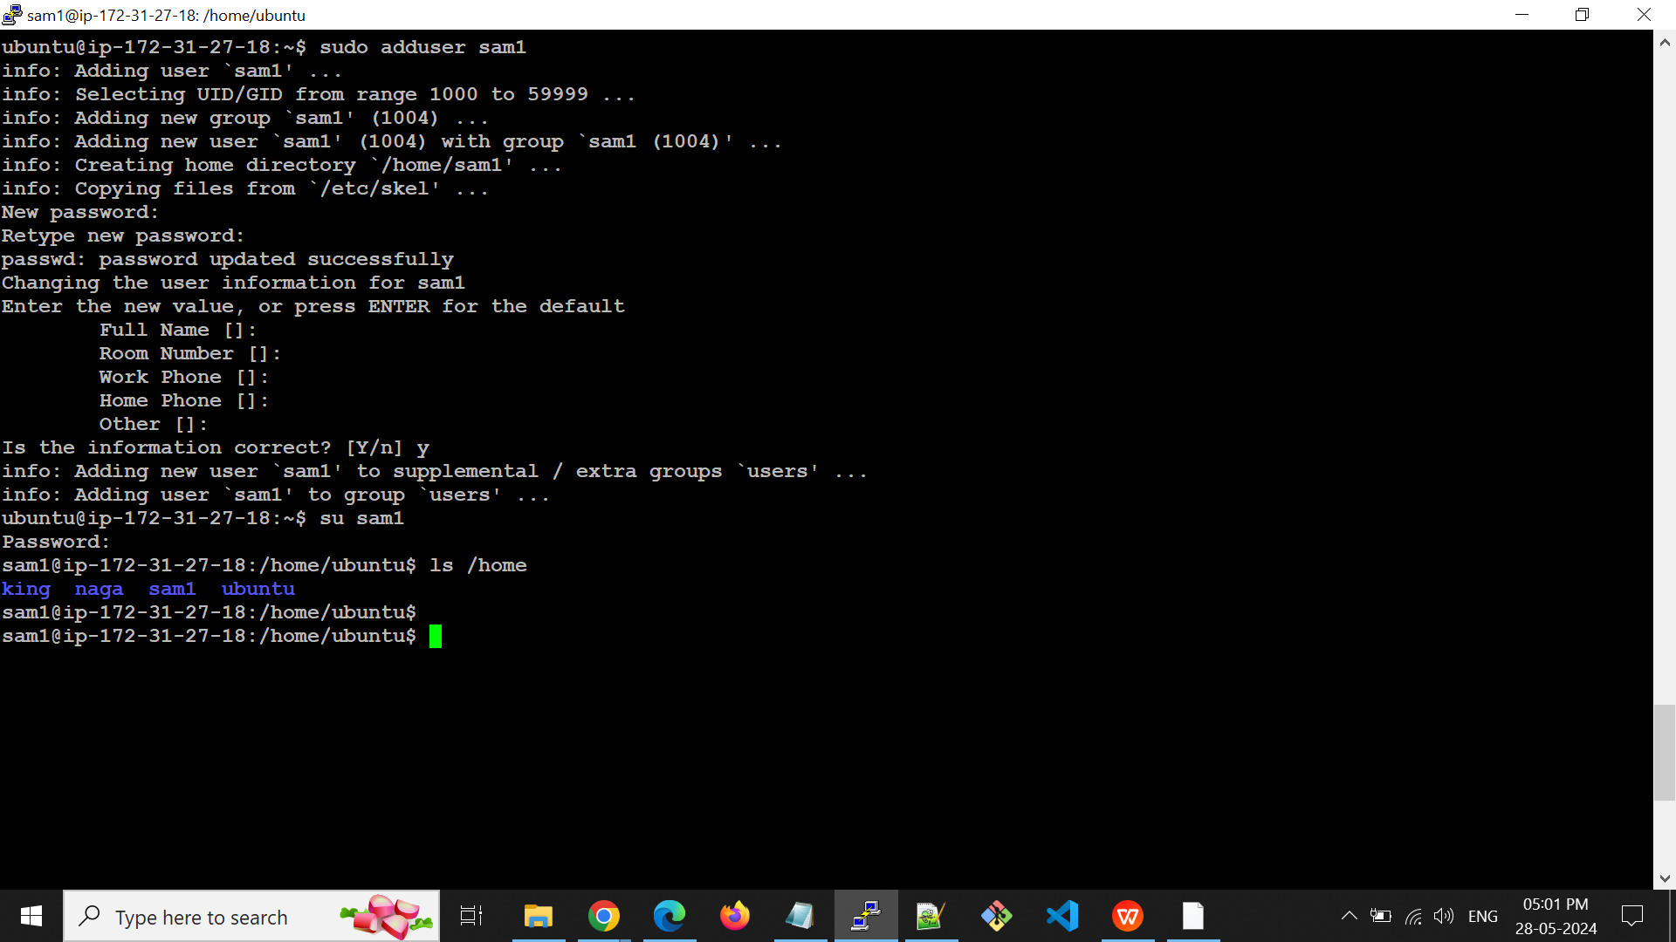

1. **Switch the user and create directory including its sub directory under newly created home directory.**

* The **su** command allows you to switch to another user account.

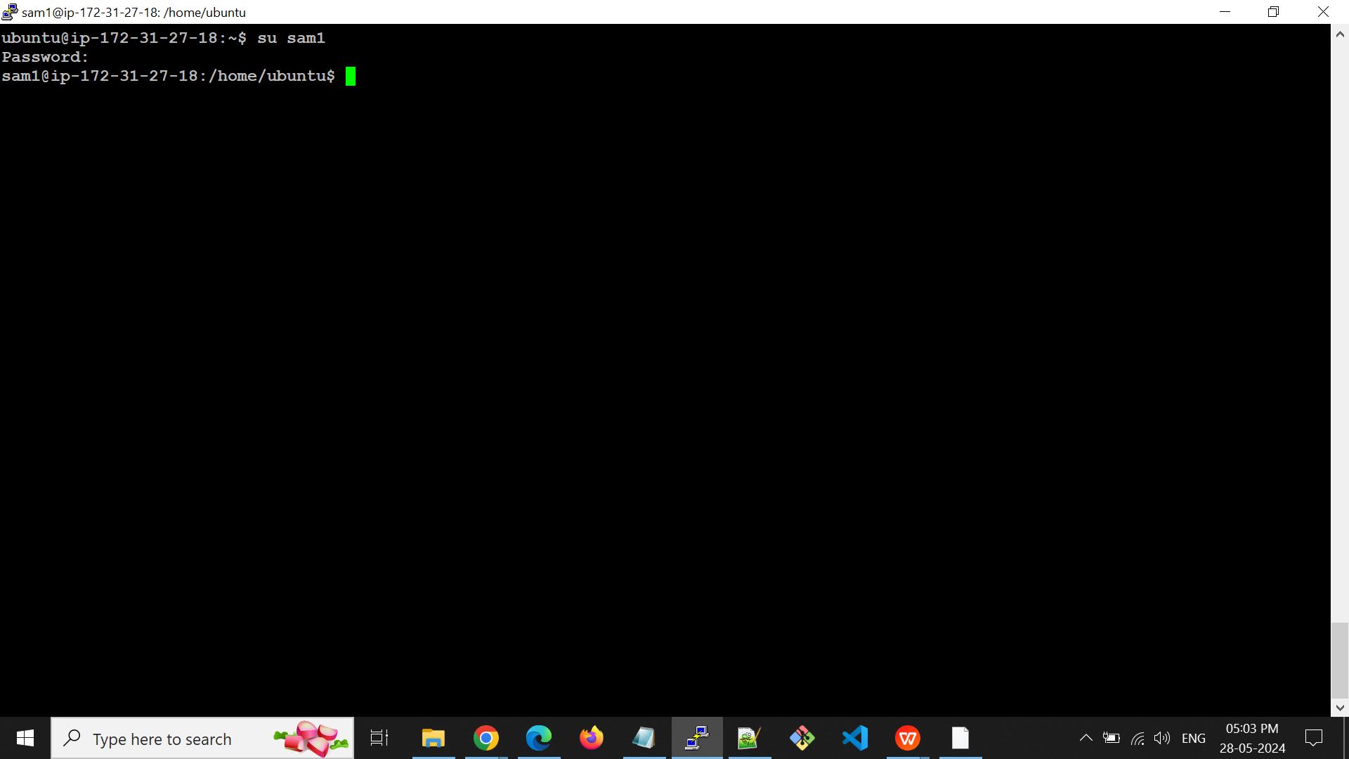

* create a directory and subdirectory under the new user's home directory. Use the **-p** option with **mkdir** to create the full path, including any intermediate directories that do not exist.

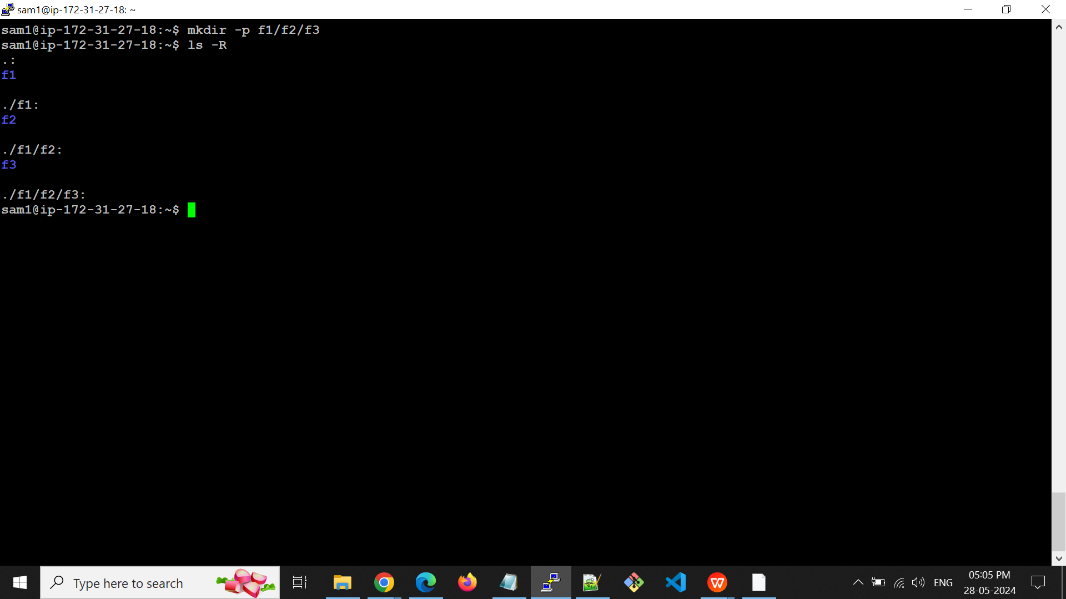

1. **Create file using cat and echo command**

* The cat command is commonly used to display file contents, but it can also be used to create files and input text interactively.

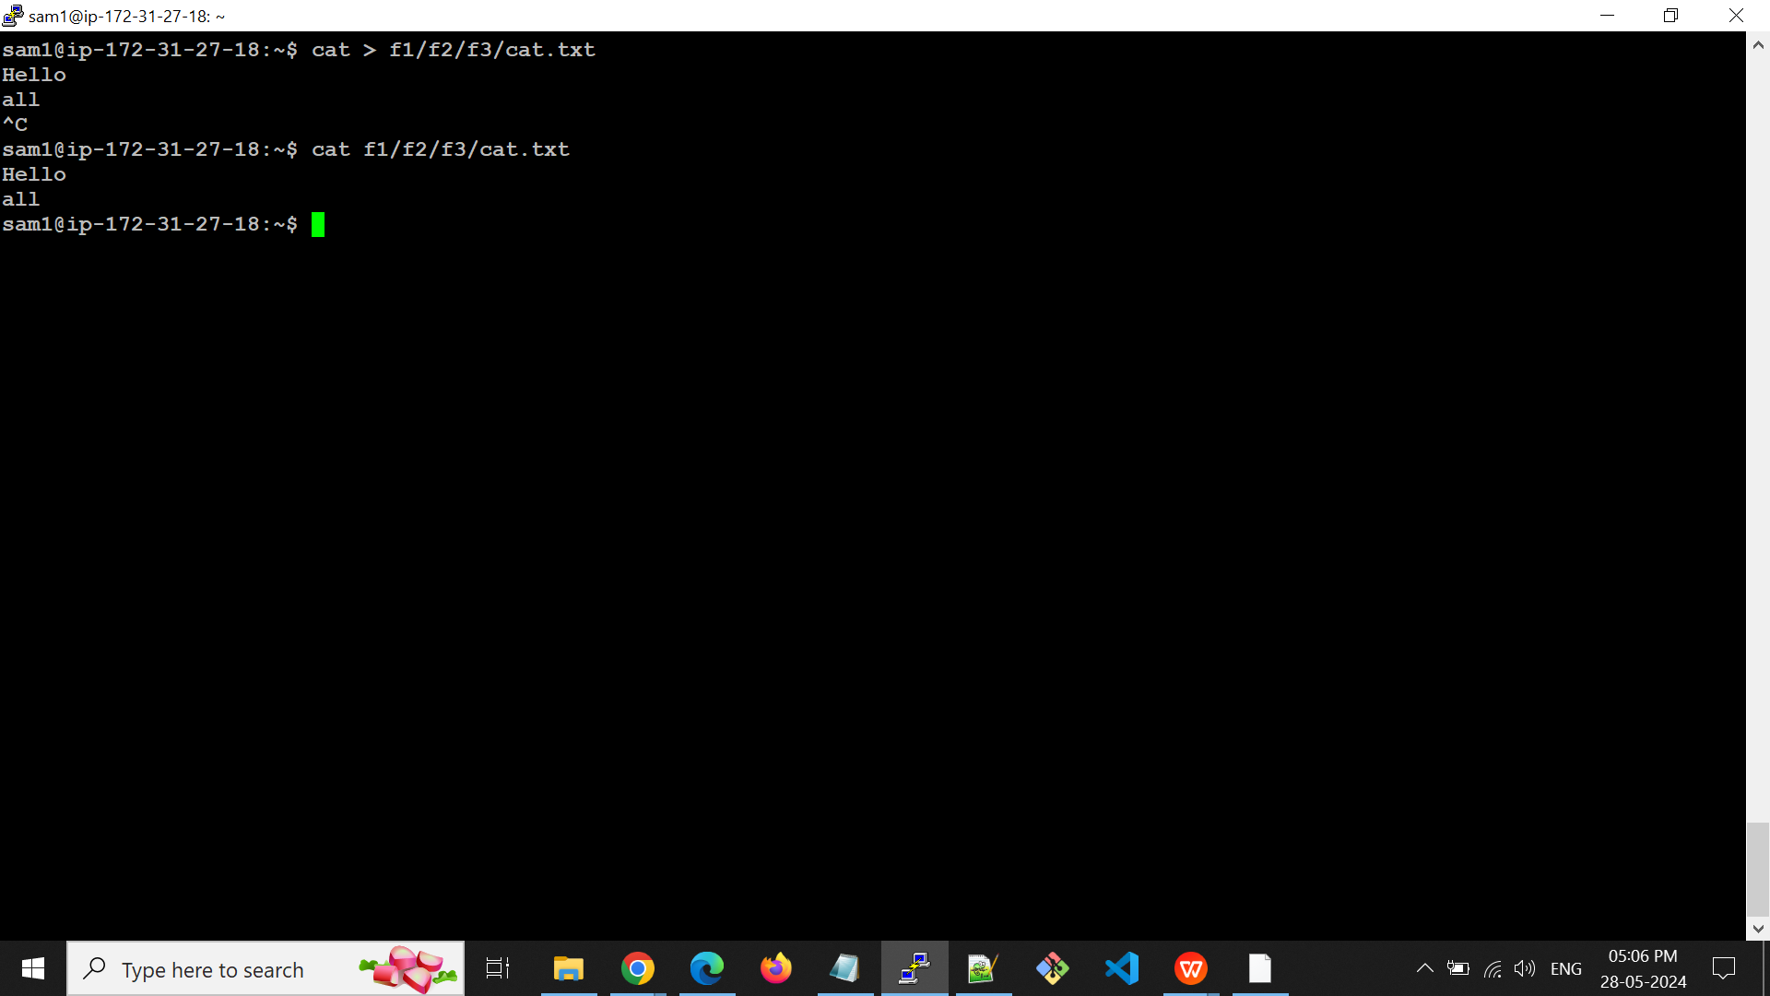

* The echo command outputs the text you provide to the terminal, but it can also be used to write text to files.

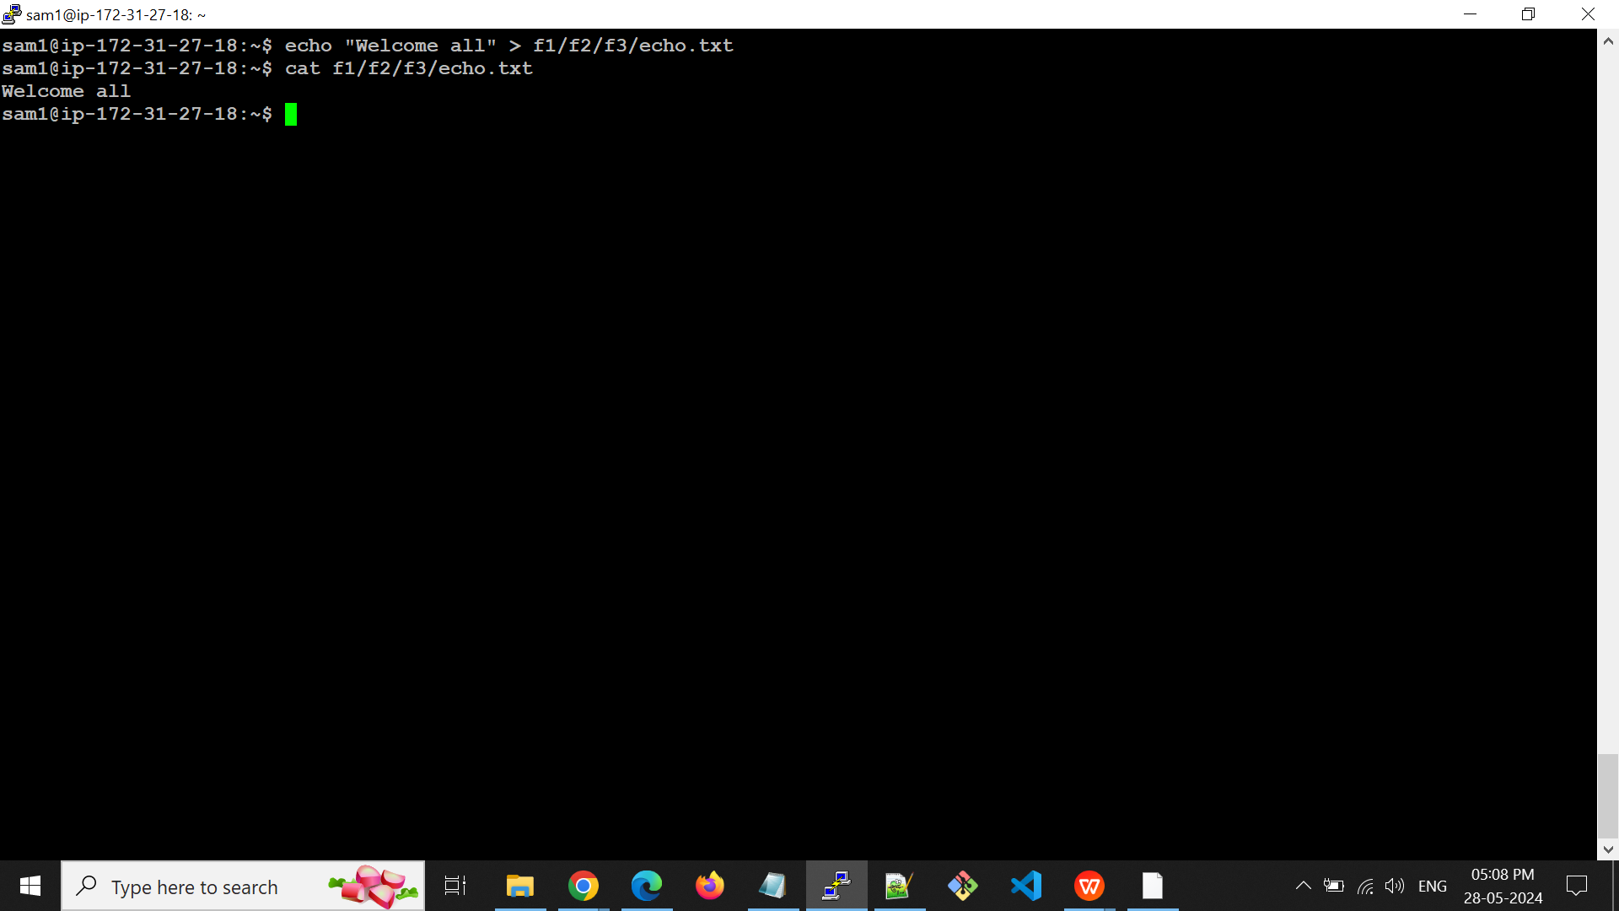

1. **Change the executable file permission for the file**

* The **chmod** command allows you to modify the permissions of a file. To make a file executable, you need to add execute permissions. You can do this using symbolic mode or numeric mode.

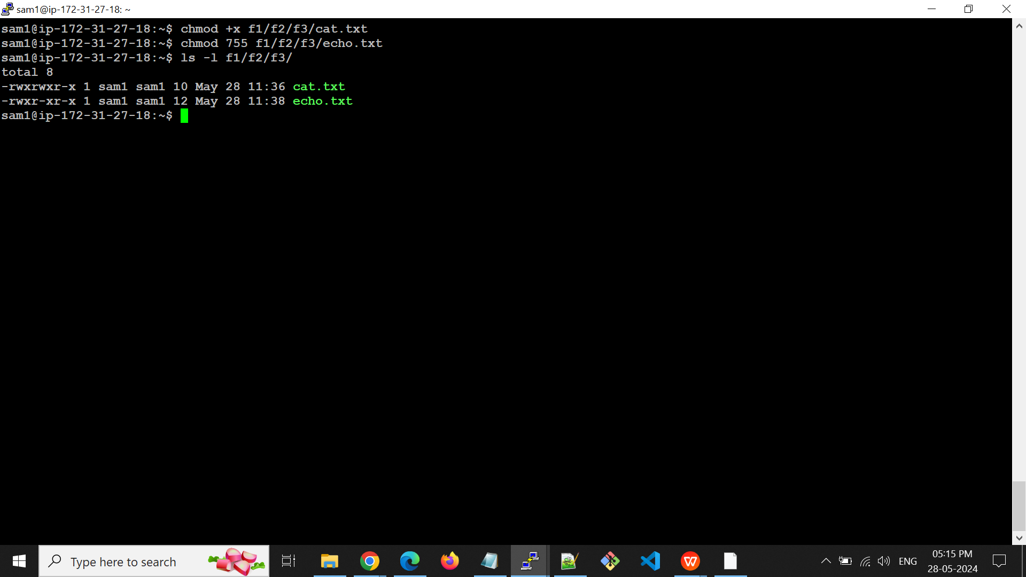

1. **Change the owner of the file**

* The **chown** (change owner) command allows you to specify a new owner for the file.

**Error:**

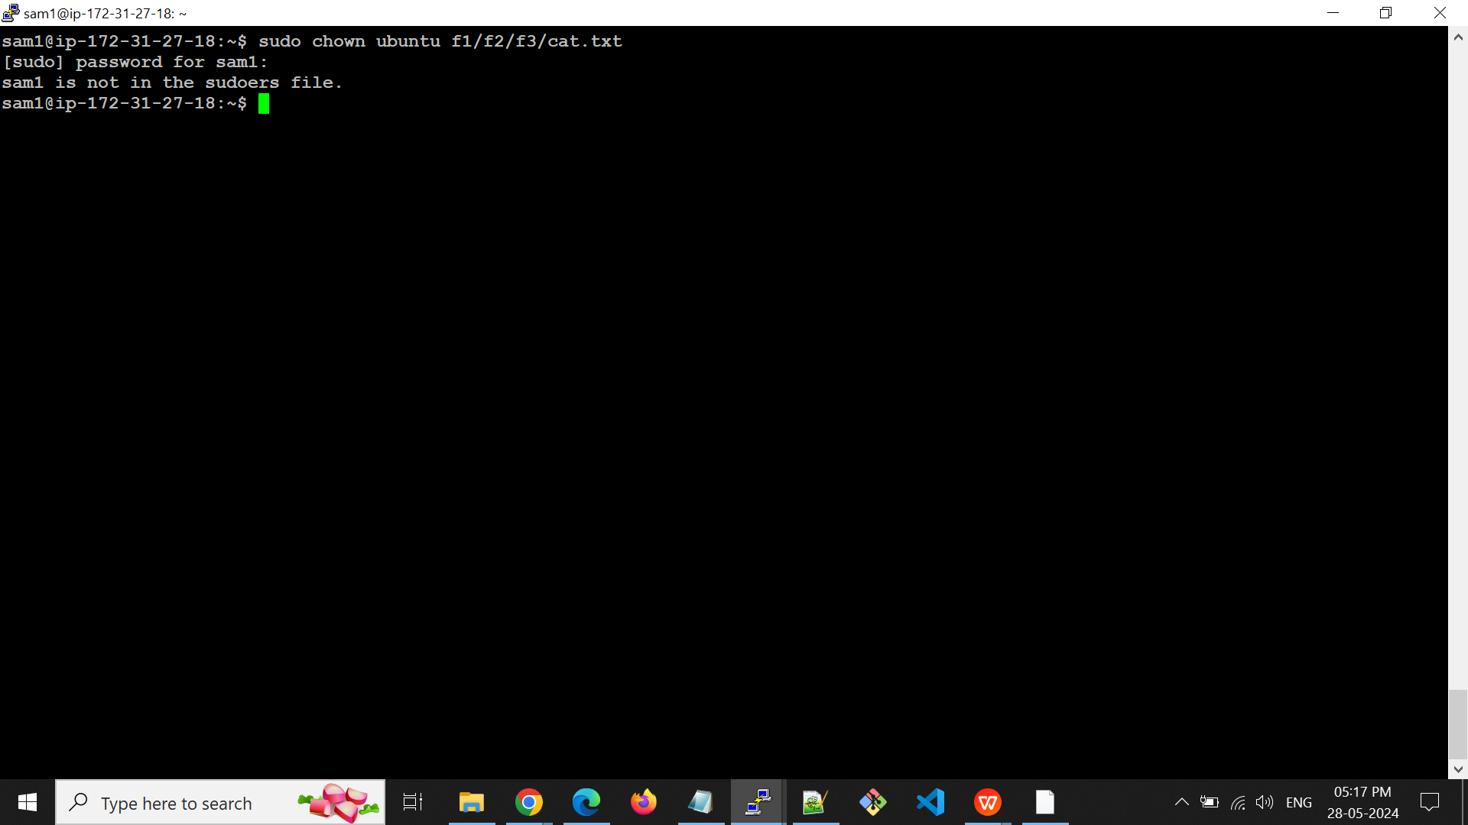

**Solution:**

* Switch to a User with **sudo** Privileges
* Edit the **sudoers** File

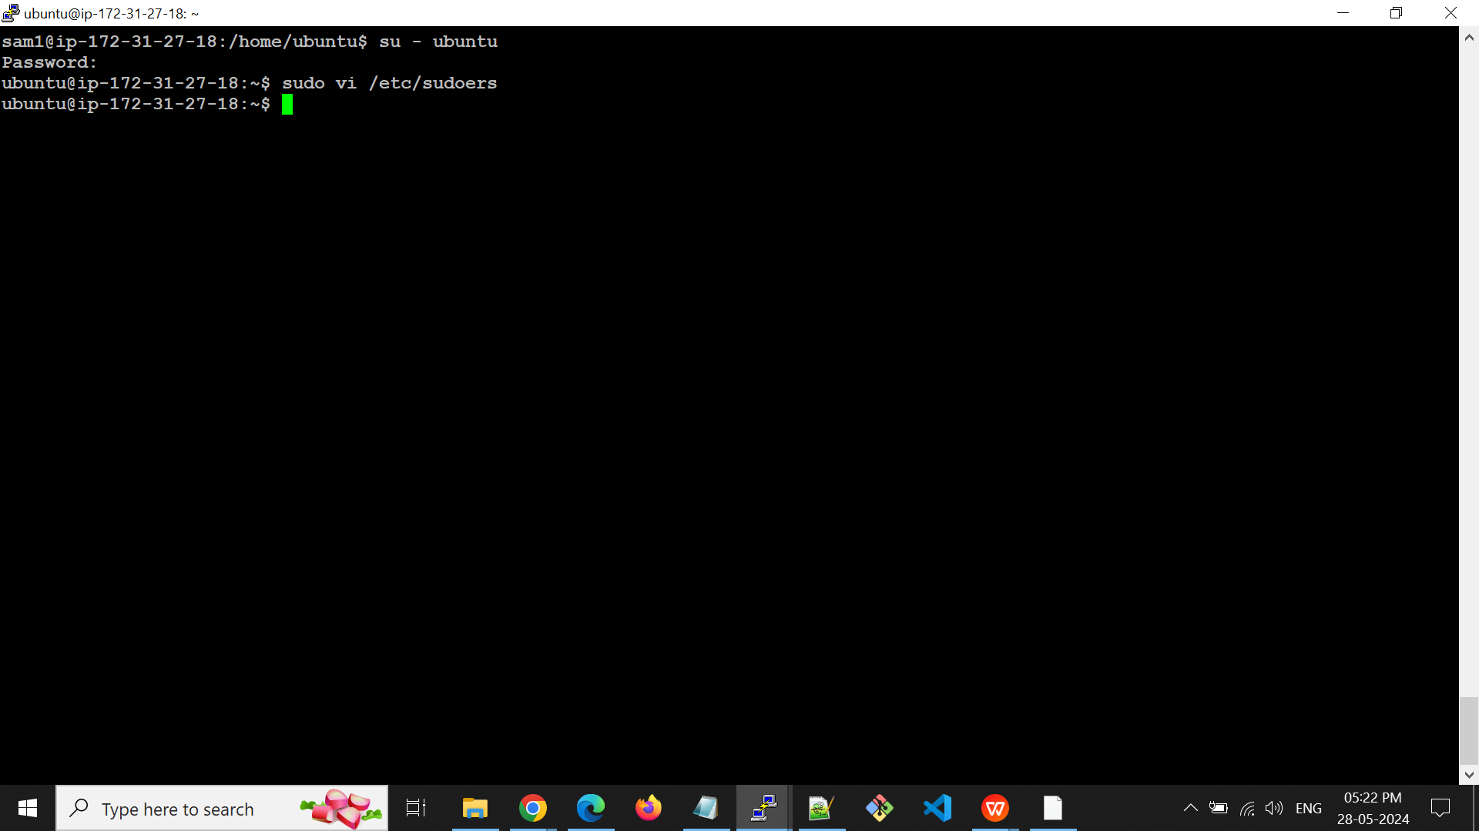

* Add sam1 to the **sudoers** File
* Save and Exit

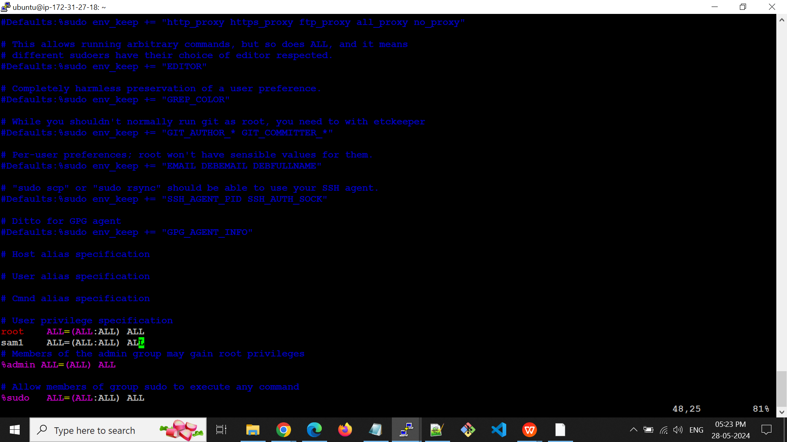

* Now we can see the file owner changed from **sam1** to **ubuntu** for cat.txt

